# CS 255 System Design Document Template

## UML Diagrams

### UML Use Case Diagram

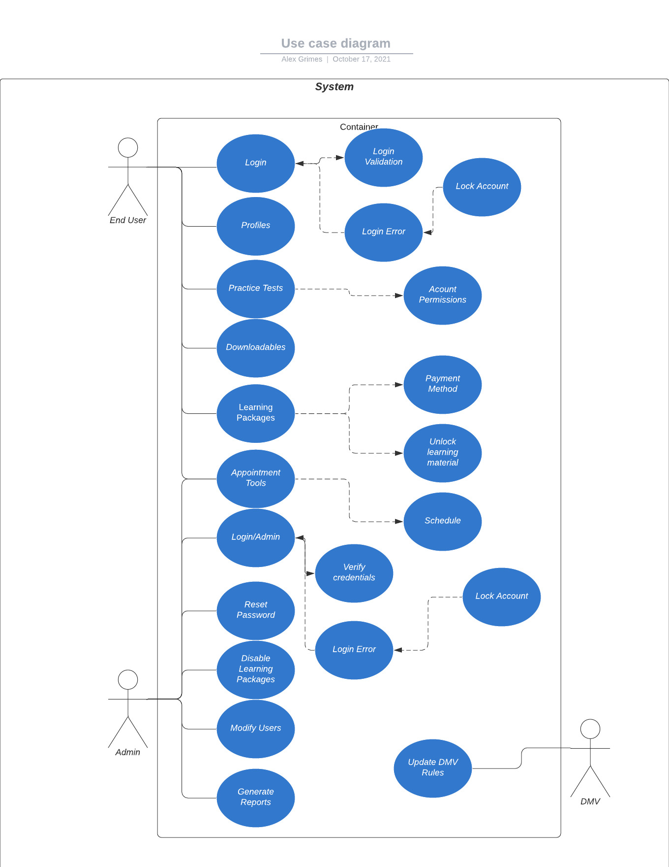

### UML Activity Diagrams

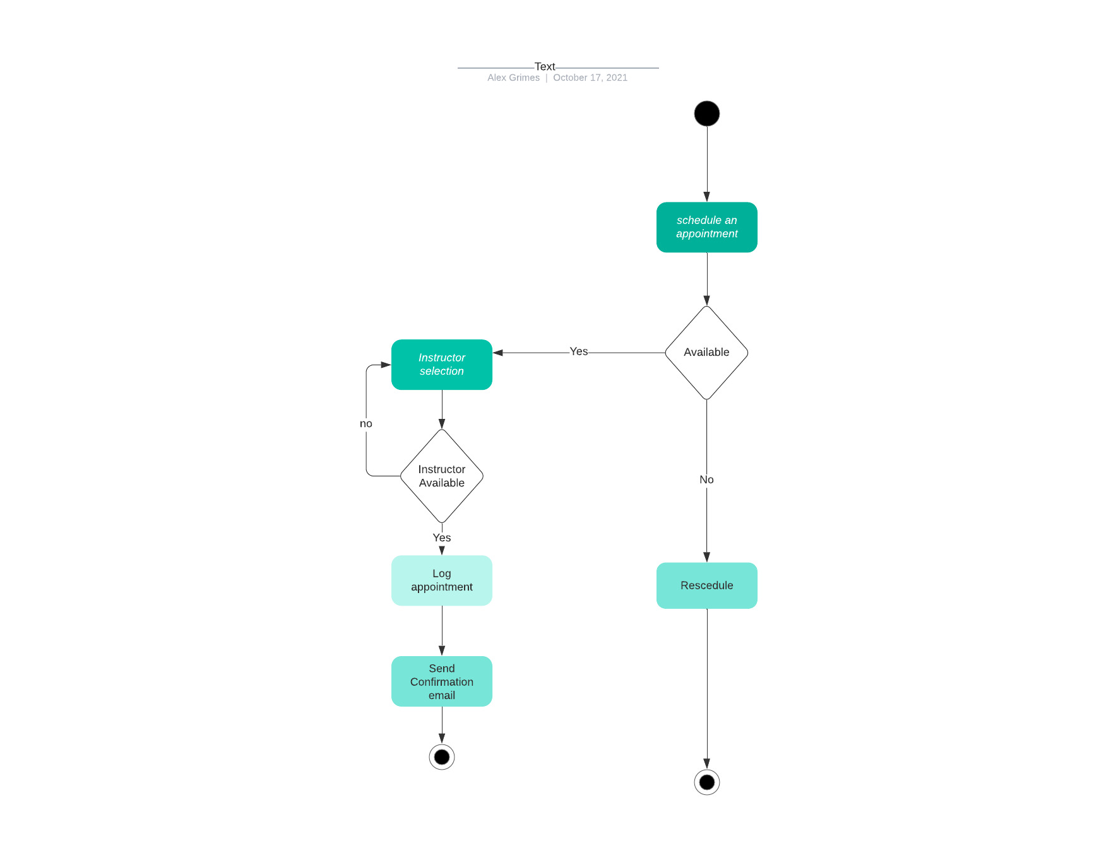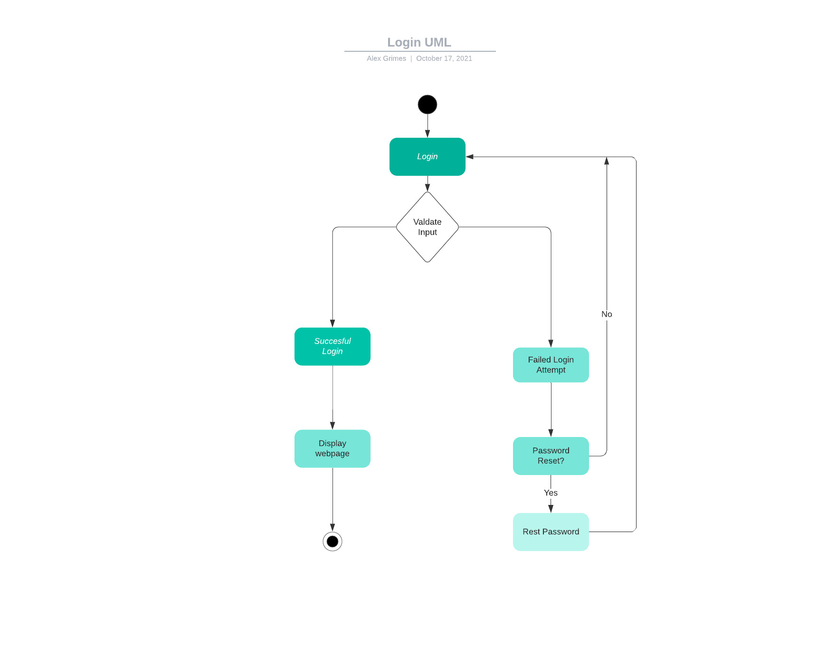

### UML Sequence Diagram

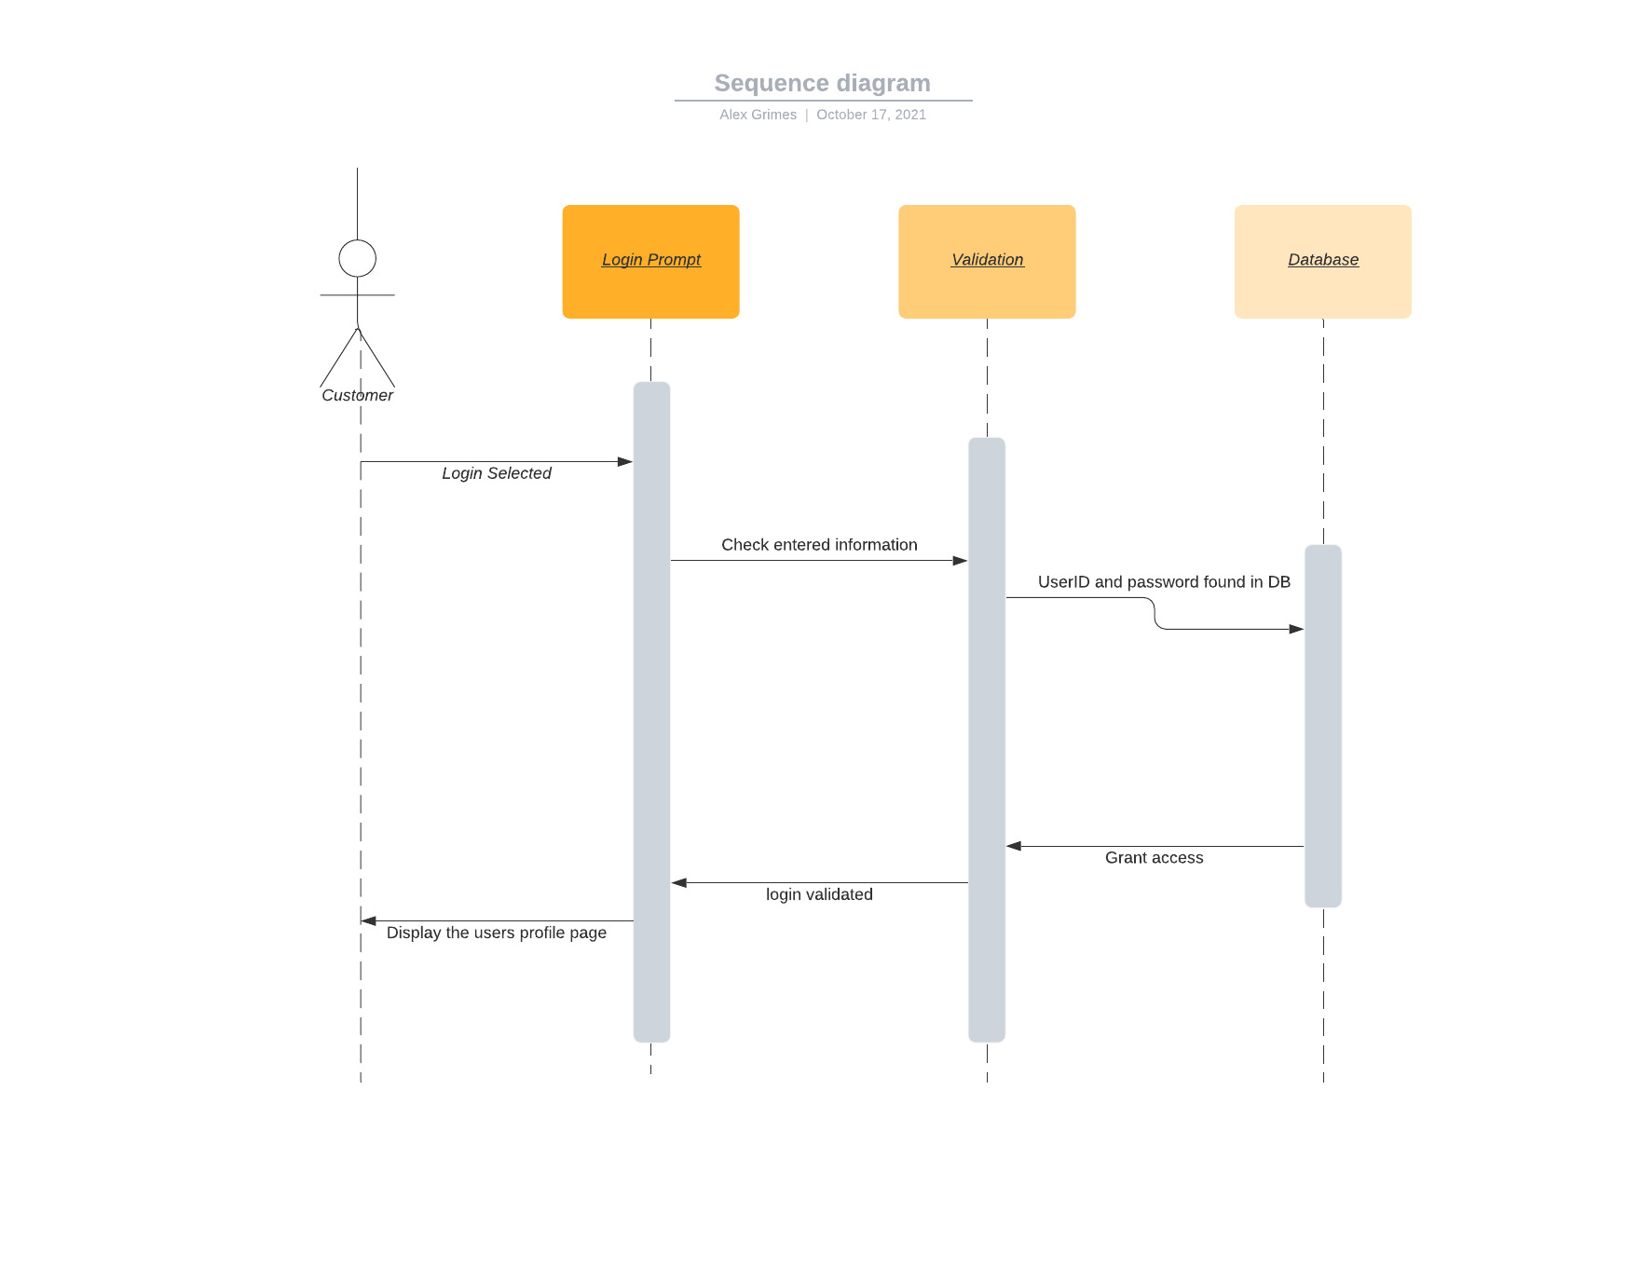

### UML Class Diagram

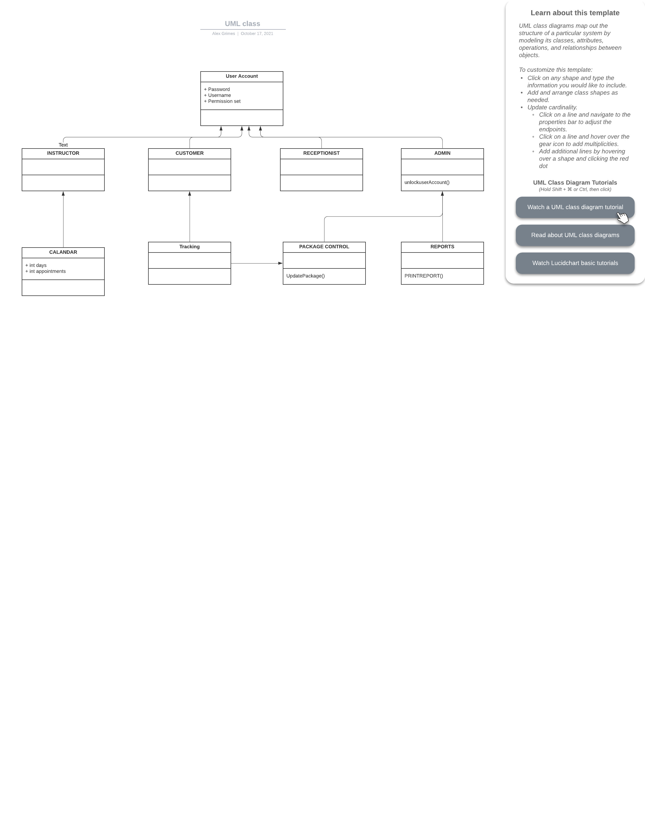

## Technical Requirements

*[Based on the diagrams you have created, describe the technical requirements of your system. These requirements should address the required hardware, software, tools, and infrastructure necessary for your system design.]*

* System will be a website making it cross platform as desired.
* System will need to. Be able to process users requests for appointments and learning.
* The system will need to be scalable and upgradeable.
* Cloud based system will require a cloud provider to be selected and paid
* The system will have account validation and authorization.
* The system will use previously stated authorization to grant various access levels
* The system will allow for multiple subscription levels for the users
* The system will allow users to access learning material and practice tests
* The system will track and provide appointment information to users
* The system will track progress through courses, tests, and other learning material provided by DMV